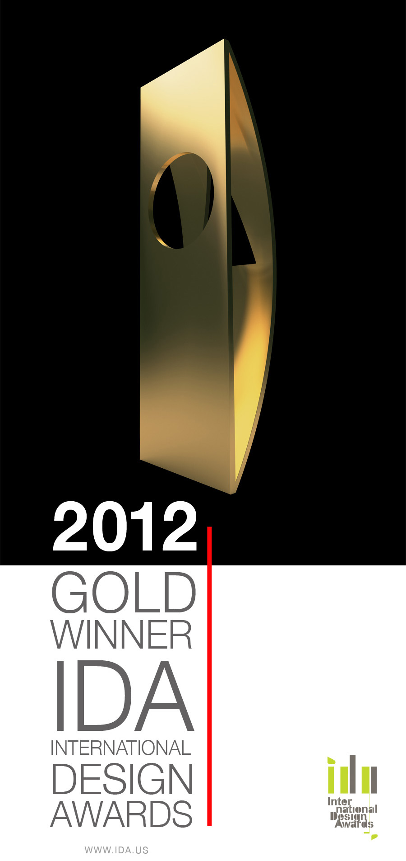

Baffle Ceiling System Featured At PHX Sky Train™ Station

Wins Prestigious Design Award

The High Profile Series™ From Hunter Douglas Architectural Products

Awarded First Prize for Product Design From The International Design Awards

NORCROSS, GA (May 2013) – Hunter Douglas Architectural Products’ High Profile Series™ Baffle Ceiling System earned First Prize for Product Design in the Transportation category from the International Design Awards. The International Design Awards exist to celebrate the world's most visionary designers, discover new and emerging talent, and promote the appreciation of design worldwide.

The High Profile Series baffle ceiling system was engineered for the new three-level, 33,600 square foot station that featured ceiling heights ranging from 10’ to 40’. The baffle ceiling system allows visual aesthetic screening and provides installers and service trades unobstructed point-access via a sliding attachment mechanism that can create openings wherever required.

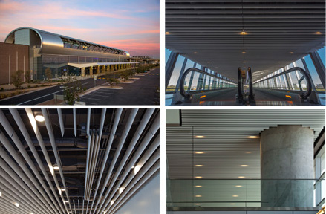

-more-
“We are very proud of this achievement and the recognition we have received from the International Design Awards and its esteemed panel of judges,” said Ron Rice, General Manager at Hunter Douglas Architectural Products. “The PHX Sky Train™ as a total team effort. Working in conjunction with HOK and the constructors T-P Acoustics, we were able to engineer and supply a robust, precise and point-accessible baffle ceiling system for one of Phoenix’s newest landmarks.”

The design team members were Station Architect HOK, Design Lead/Engineer Gannett Fleming and General Contractor Hensel-Phelps. The team also included Ceilings & Interior Systems Construction Association (CISCA) members: Subcontractor T-P Acoustics, Hunter Douglas representatives Lanton Associates and Manufacturer Hunter Douglas Architectural Products.

Key Features:
- Extruded aluminum profiles with precise fit and finish.
- Seamless baffles to 20 feet in length.
- High recycled content.
- Client-specific shapes and materials.
- Integrated lighting options.
- Robust Unistrut® support system, or 15/16” t-grid suspension.
- Paint, anodized or wood veneer finishes.
- Patented locking mechanism.
- Strength to support signage.
- Class A Fire Rated, per ASTM E-84.
- No VOCs: No added urea-formaldehyde.
- GREENGUARD GOLD Certified.

About the Competition
Architects and designers of interiors, fashion, products, and graphics submitted entries from over 65 countries throughout the world, proving IDA's global emphasis. Judging was a rigorous process, with winners receiving publication of their work in the 2010 International Design Awards Book of Designs, to be distributed nationwide; promotion to 100,000 design professionals and potential clients worldwide; year-long coverage on the International Design Awards website; and critical acclaim by our distinguished panel of judges.

Jurors included Alice Blackwood - Editor, Design Quarterly; Lise Coirier - Editor-in-Chief, TL; Hans Fank - Editor-in-Chief, OBJEKT International; Aaron Kenedi - Editor-in-Chief, Print; Rebecca Epstein Kong - Co-Founder, Artware Editions; Raj Nandan - Managing Director, Indesign Group; Laurence Ng - Publisher, IdN; Josh Rubin - Editor-in-Chief, Founder, and Publisher, Coo2l Hunting; and other leaders and editors in the design community.

About Hunter Douglas Contract
For more than 60 years, the architecture and design community has specified contract products from Hunter Douglas, the world leader in window coverings and a major manufacturer of architectural products. A tradition of bringing breakthrough products to market makes Hunter Douglas the choice for an array of innovative contract solutions.

###

